**Unit 3 – Reading 2**

**Uniform Acceleration**

Back in Unit 2, we determined that the area under a velocity-time graph illustrated the displacement of an object during the time interval shaded. In the situation shown below, we can find the displacement for the entire 6 seconds of the motion. Please note, when the velocity is constant, the area is a rectangle… so, we calculate the area using the area of a rectangle.

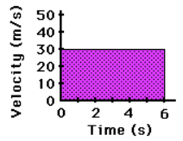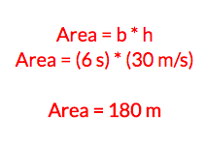

We can also find the displacement during any portion of the motion.

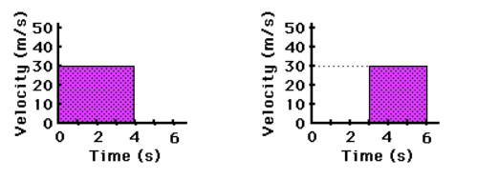

The graph on the left illustrates how to find the displacement for just the first 4 seconds.

(From t = 0 seconds to t = 4.0 seconds.)

The graph on the right illustrates how to find the displacement for the last 3 seconds.

(From t = 3.0 seconds to t = 6.0 seconds.)

But, what do we do when the velocity is *not* constant? Is the area still the displacement?

Of course. But, this leads to a variety of problems.

Can we approximate the displacement using rectangles? If so, which rectangle do we use?

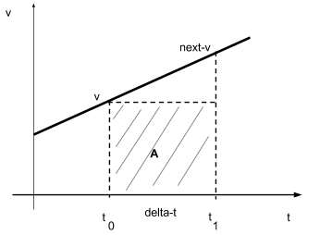

If we consider, using the area based on the rectangle to the left, we will note that the area certainly doesn’t appear to match the total area that we are looking for. If we use the height of ‘v’, and the width of ‘delta-t’… the area appears to be too small.

And if we considered doing that for all the time intervals, we will see that the overall displacement is far too small compared to what it should be.

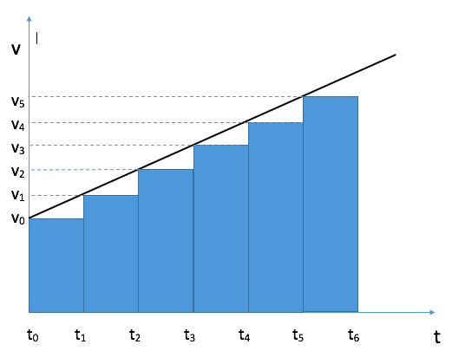

As the graph to the right illustrates there is a large portion of the shape that is not shaded, and therefore, using the ‘v’ value, our area is much too small when looking at the full motion.

Above each rectangle sits a triangle that we did not consider, and so we have not approximated the motion to the best we could.

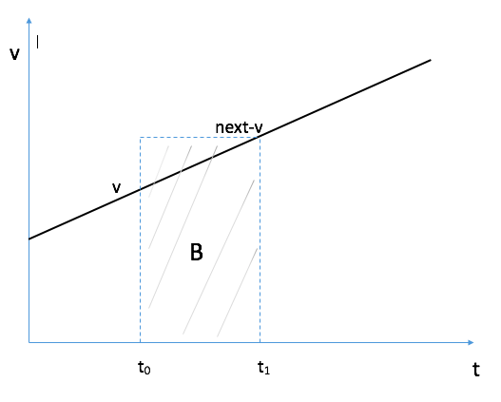Next, we consider using the ‘next-v’ value to approximate the displacement.

But, as we had before, we have a problem again. The area of the rectangle now extends beyond the space under the velocity versus time graph.

Once again, we are not approximating as best we can, this time, our space is too large, and so we are overestimating the displacement of the object.

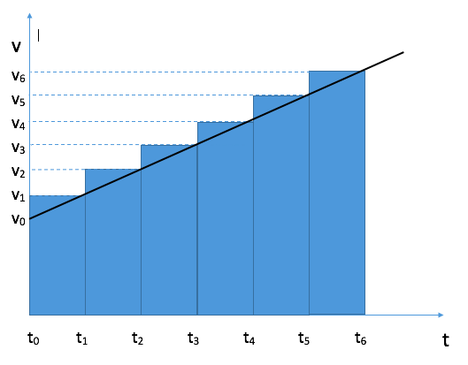

This time, when we look at the entire motion, the area shaded by the rectangles extends beyond the space we want to consider, and the result is that we are approximating the area to be larger than it is supposed to be.

So, we are left with one option that is too small, and one option that is too large.

Were we doing all this by hand, the simple solution is to define the trapezoid for each of the spaces, or we can do it all at once for a given graph.

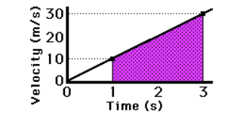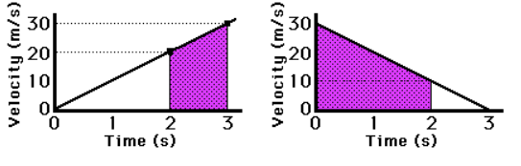

This option works well on paper, but it is a struggle when programming a computer to calculate these small displacements for each time step that takes place. We need an alternative that won’t over shoot, nor under shoot.

The computer program can tell us both the current velocity and the velocity at the next clock reading we are using.

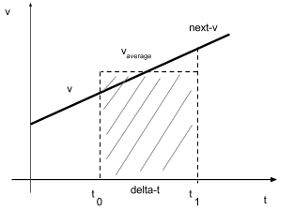

So, the computer can take the ‘v’ value it is currently using, AND the ‘next-v’ it is about to find, and we can find the average-v for this time interval.

(Recall, back at the beginning of this unit, we found the average velocity for a time interval and approximated the average velocity by finding the slope of that value and it represented the approximation of the instantaneous velocity at the midpoint of that time interval. As such, the velocity at the midpoint *on this graph*, can be used to determine the area of the total section.)

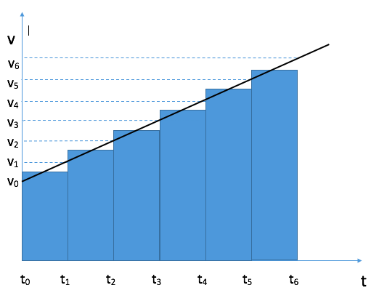

Looking at all the intervals for the graph, we notice that just as before, the area is a bit below the line we are trying to match, AND we are a bit over the line as well.

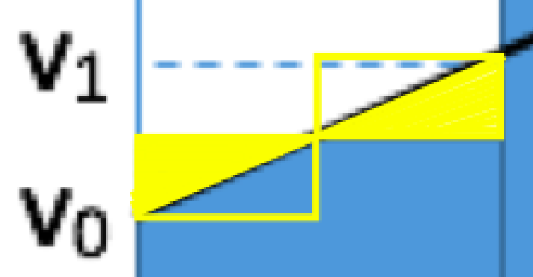

If we zoom in on this

section of the graph an interesting thing occurs.

The amount of the area ABOVE the line, is precisely the amount that the area is BELOW the line. The net results is that it evens out and perfectly fits the area we are ultimately trying to find. SO, we can approximate the area of the graph by using a series of rectangles, where for each time interval we use, we choose the average velocity to determine the appropriate height of the rectangle.

Algebraically, the average velocity for an uniformly accelerated object was:

$v_{avg}= \frac{∆x}{∆t}$ $∆x= v_{avg}* ∆t$

Rearranging the equation on the left, we get the equation on the right – which is what the area of the rectangle above ultimately is for each time interval (Δt).